**History of survey station relocations:**

Survey stations have generally followed a fixed-station sampling design since its inception in 1988. There have been major sampling station redistributions in survey 1991, 2006, 2012 and 2013. Survey stations in years following these redistributions then tend center on these locations.

However, the ability of the survey vessel to target previous sampling locations was limited due to imprecise positioning systems at the time. Even with the advent of GPS, drifting from a fixed station from the previous year could and did occur, depending on the practices of the on board captain at the time.

The following shows results from an analysis whereby the entire set of survey sampling locations from 1988 onward were assigned to a station identifier if found within a 0.75km radius of it. This resulted in a set of ~2000 sampling stations. From these, it was then possible to track how loyal various surveys were to the fixed stations from previous years, and also showed when survey redesigns occurred.

**Proportion of trawlable survey bottom:**

The proportion of the survey area represented by trawlable bottom was calculated using tow stations from 2012 and 2013. Because of redesigns in the survey, completely new sets of sampling stations were assigned to each of these years. The proportion of tows successfully trawled on the first try was found to be 82% (n = 673).

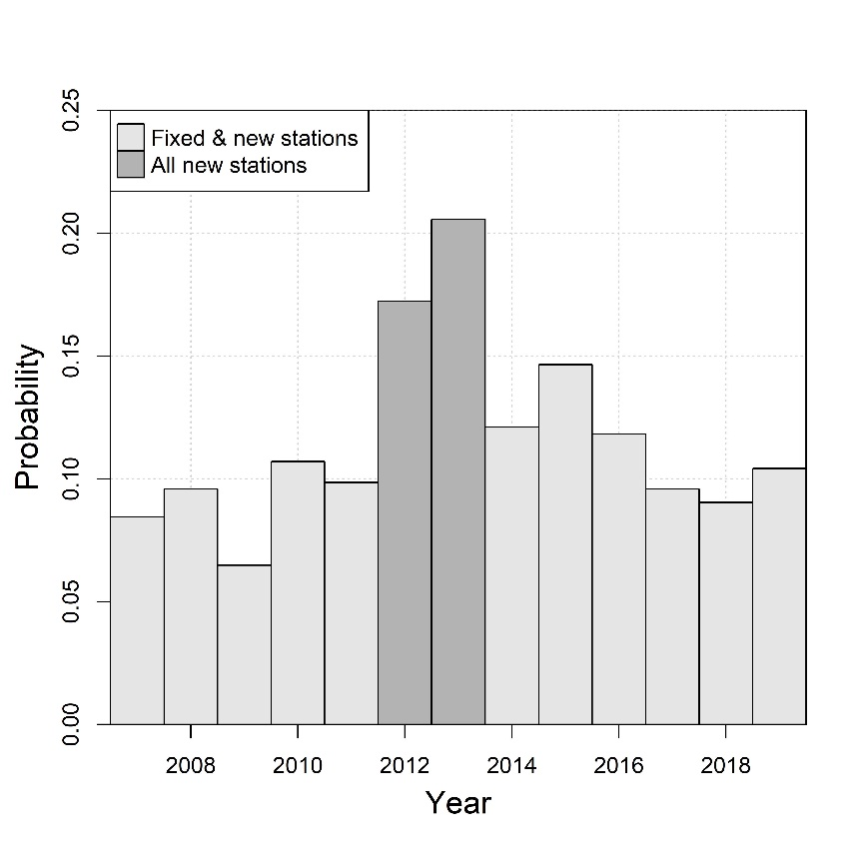

**Figure 1** : Probability of rejecting a tow on the first attempt by survey year. Survey years 2012 and 2013 were solely comprised of new trawl stations due to survey redesign, so these proportions are estimates of the untrawlable bottom for the survey area.

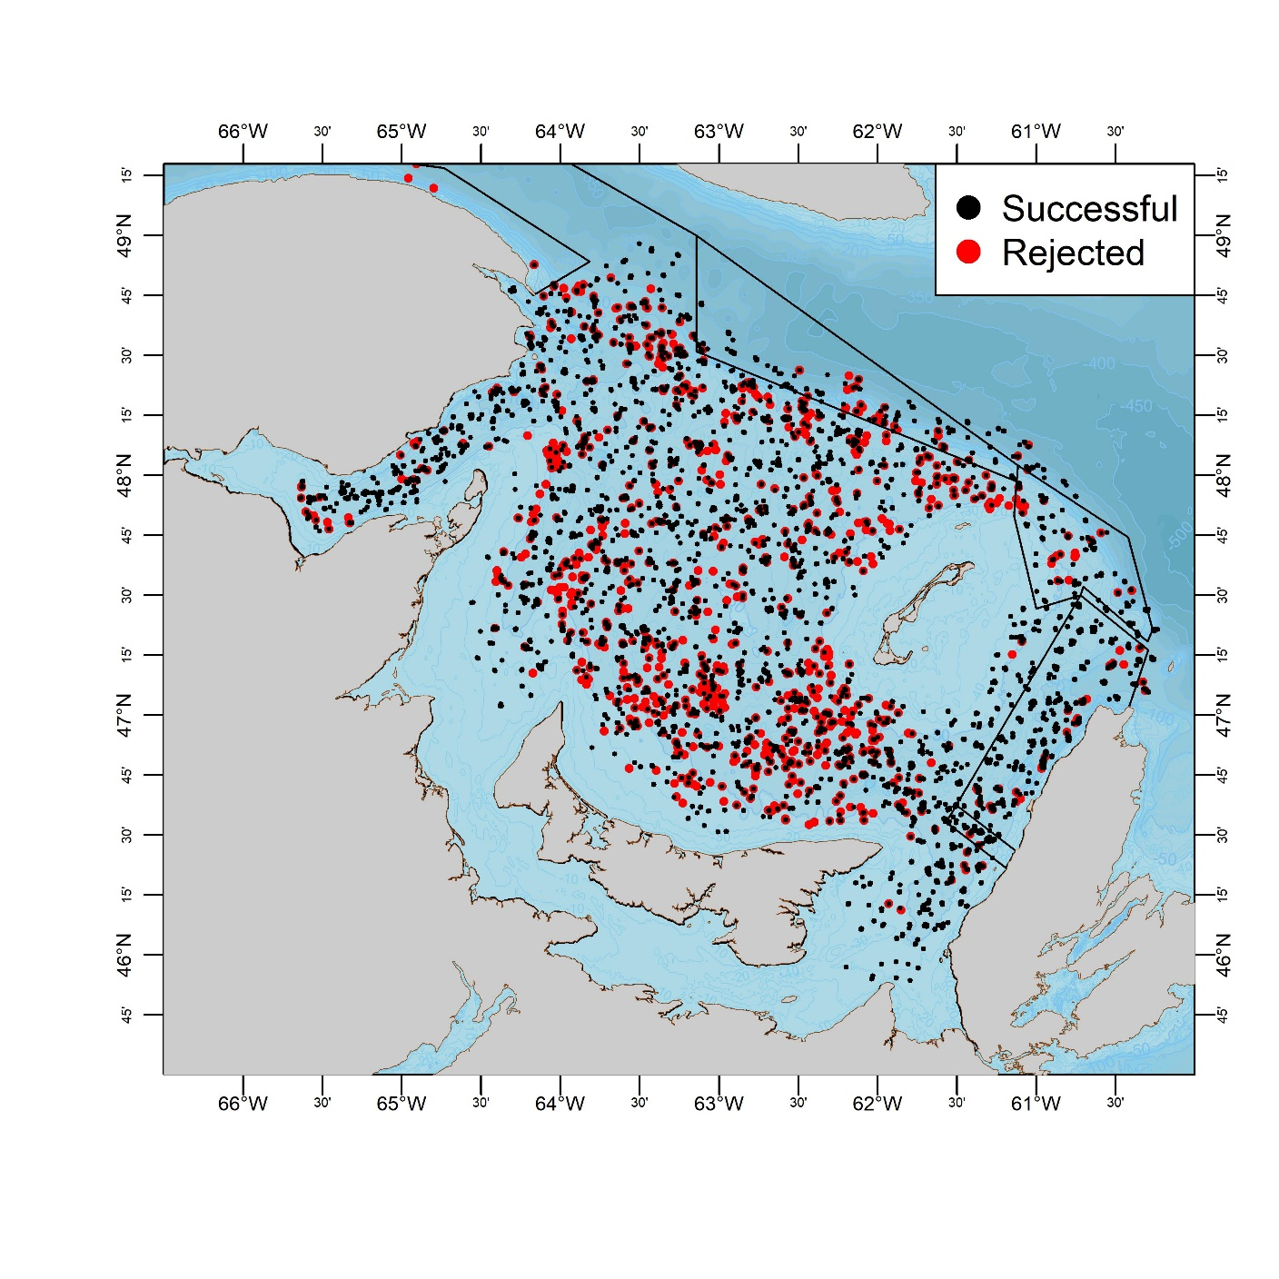

**Figure 2** : Spatial distribution of all successful (black dots) and rejected (red dots) tows from the snow crab survey 1988-2019.

**Table 1** : Summary of survey stations having a fixed or new location relative to the those of the previous survey year. To derive this table, tows were identified to a particular station if the center point of the tow was located within a radius of 0.75 km of this station. Also shown if the total number of rejected tows.

|  |  |  |  |  |  |  |  |
| --- | --- | --- | --- | --- | --- | --- | --- |
|  |  | **Stations** | | |  |  |  |
| **Year** | **Vessel** | **Fixed** | **New** | **Total** | **Rejects** | **Grid size** | **Comment** |
| 1989 | Emy Serge | 63 | 92 | 155 | 16 | 10'x10' |  |
| 1990 | Emy Serge | 40 | 172 | 212 | 43 | 10'x10' |  |
| 1991 | Emy Serge | 56 | 159 | 215 | 19 | 10'x10' |  |
| 1992 | Emy Serge | 59 | 174 | 233 | 9 | 10'x10' |  |
| 1993 | Emy Serge | 122 | 86 | 208 | 11 | 10'x10' |  |
| 1994 | Emy Serge | 128 | 131 | 259 | 23 | 10'x10' |  |
| 1995 | Emy Serge | 152 | 109 | 261 | 38 | 10'x10' |  |
| 1996 | Emy Serge | 41 | 31 | 72 | 3 | 10'x10' | Partial survey only |
| 1997 | Emy Serge | 127 | 132 | 259 | 18 | 10'x10' | Relative to 1995 |
| 1998 | Emy Serge | 125 | 136 | 261 | 16 | 10'x10' |  |
| 1999 | Den C Martin | 151 | 126 | 277 | 26 | 10'x10' |  |
| 2000 | Den C Martin | 255 | 25 | 280 | 26 | 10'x10' |  |
| 2001 | Den C Martin | 268 | 24 | 292 | 26 | 10'x10' |  |
| 2002 | Den C Martin | 270 | 49 | 319 | 24 | 10'x10' |  |
| 2003 | Marco Michel | 306 | 11 | 317 | 44 | 10'x10' |  |
| 2004 | Marco Michel | 314 | 33 | 347 | 27 | 10'x10' |  |
| 2005 | Marco Michel | 283 | 72 | 355 | 51 | 10'x10' |  |
| 2006 | Marco Michel | 209 | 145 | 354 | 37 | 10'x10' | Partial redistribution of stations |
| 2007 | Marco Michel | 351 | 4 | 355 | 47 | 10'x10' |  |
| 2008 | Marco Michel | 347 | 8 | 355 | 50 | 10'x10' |  |
| 2009 | Marco Michel | 354 | 1 | 355 | 38 | 10'x10' |  |
| 2010 | Marco Michel | 354 | 0 | 354 | 47 | 10'x10' |  |
| 2011 | Marco Michel | 352 | 1 | 353 | 46 | 10'x10' |  |
| 2012 | Marco Michel | 8 | 313 | 321 | 80 | 13.1 x 13.1km | New stations / Survey design |
| 2013 | Jean Mathieu | 13 | 339 | 352 | 92 | 12.6 x 12.6km | New stations / Survey design |
| 2014 | Jean Mathieu | 306 | 47 | 353 | 56 | 12.6 x 12.6km |  |
| 2015 | Jean Mathieu | 298 | 55 | 353 | 71 | 12.6 x 12.6km |  |
| 2016 | Jean Mathieu | 314 | 40 | 354 | 55 | 12.6 x 12.6km |  |
| 2017 | Jean Mathieu | 319 | 34 | 353 | 50 | 12.6 x 12.6km |  |
| 2018 | Jean Mathieu | 315 | 39 | 354 | 41 | 12.6 x 12.6km |  |
| 2019 | Avalon Voyager II | 315 | 37 | 352 | 67 | 12.6 x 12.6km |  |

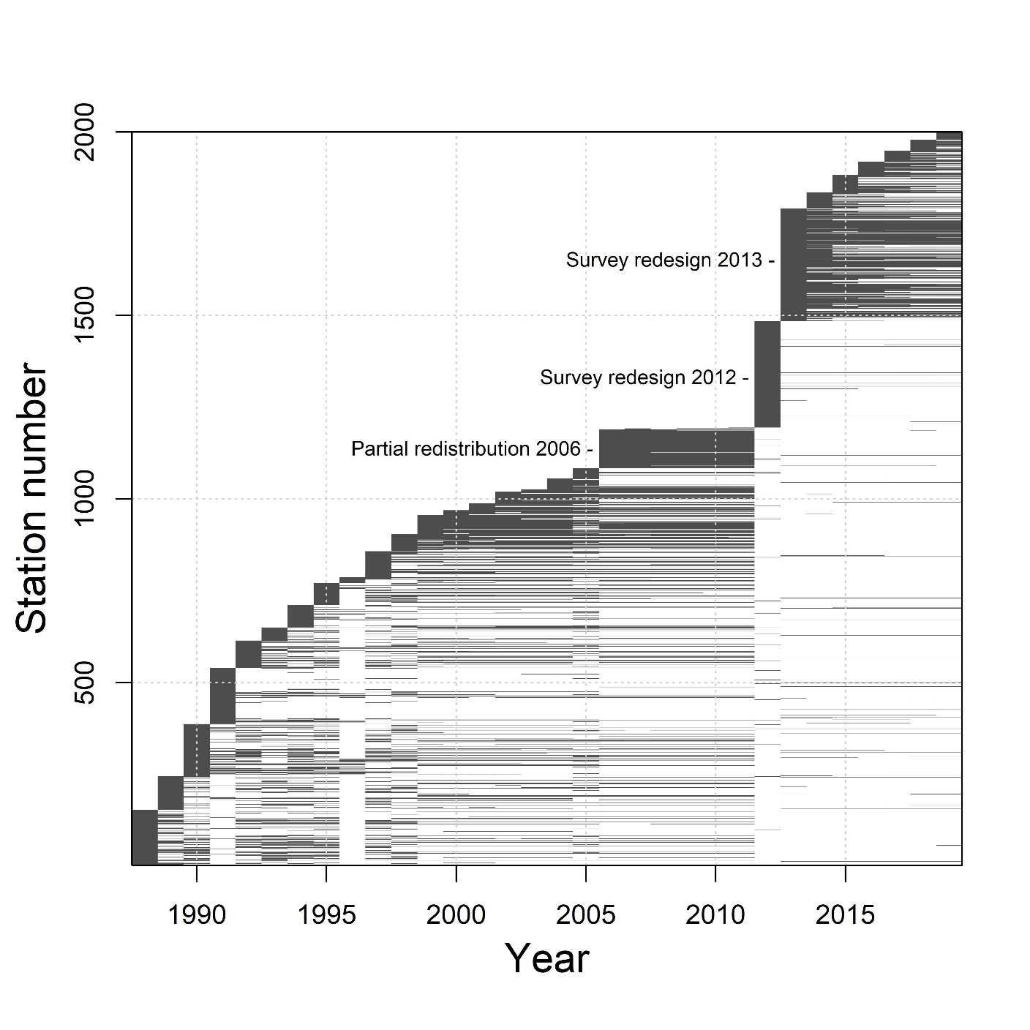

**Figure 3** : Summary of the set of 2000 or so sampling stations that the snow crab survey has sampled during its history. Sampling stations are labelled by the order of their first appearance in the survey, i.e. older stations are lower on the y-axis while newer stations are higher. A shaded line indicates that a station was successfully sampled for a particular year. Tows were identified to a particular station if the center point of a tow was located within a radius of 0.75 km of this station.

**Table 2 :** Number of survey stations grids (n = 355) with a specified number of station location changes over the 2013 to 2019 survey period.

|  |  |
| --- | --- |
| **# changes** | **frequency** |
| 0 | 177 |
| 1 | 80 |
| 2 | 43 |
| 3 | 26 |
| 4 | 13 |
| 5 | 8 |
| 6 | 3 |
| 7 | 2 |
| 10 | 2 |
| 12 | 1 |

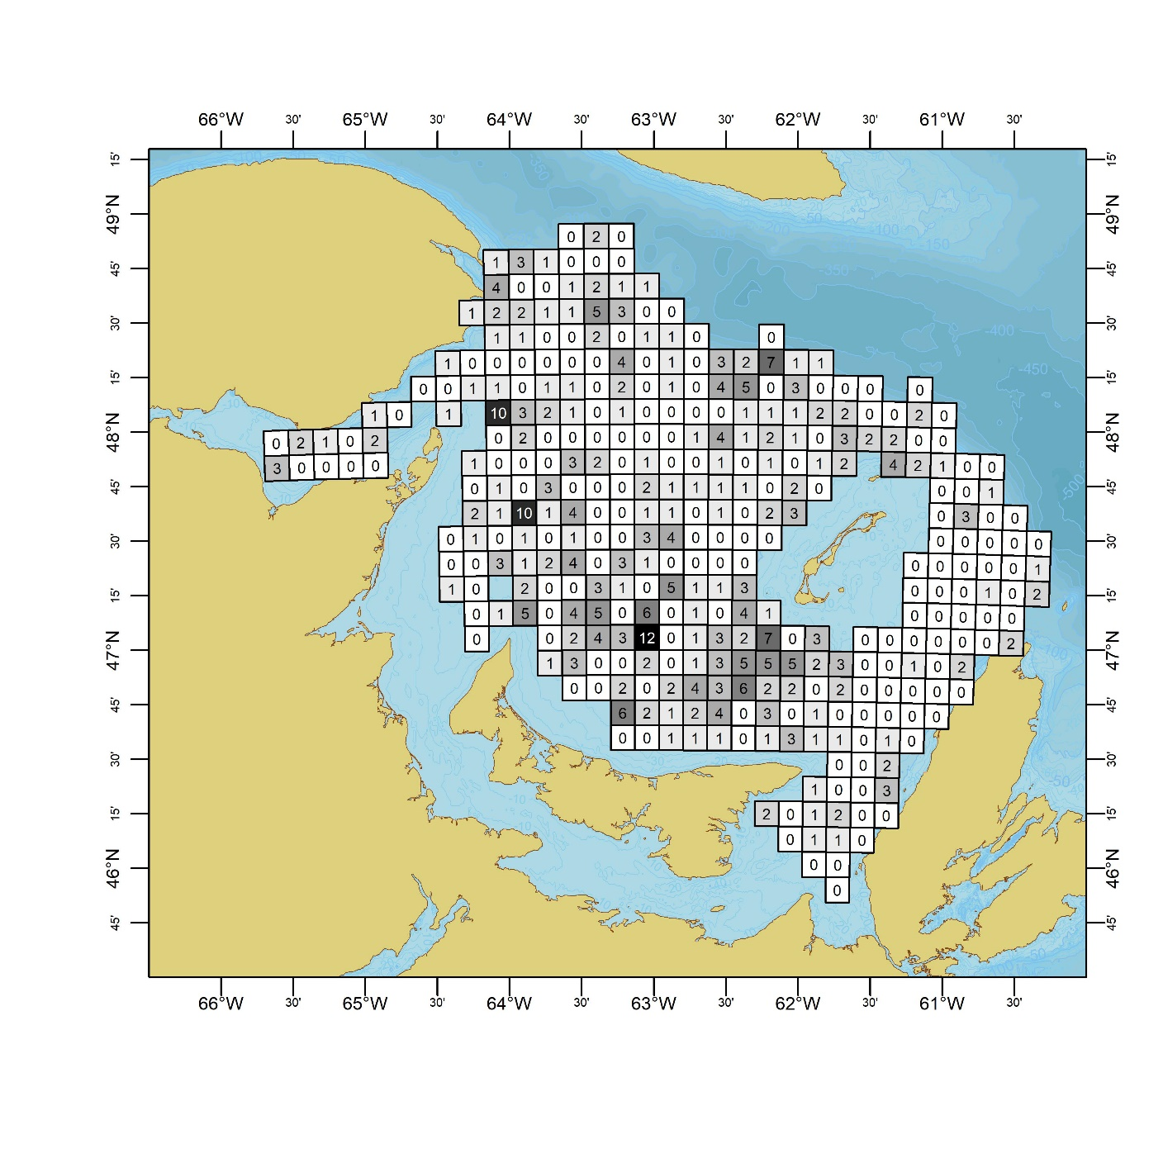

**Figure 4 :** Map of survey sampling grids and the total number of sampling station relocations which have occurred within them over survey years 2013-2019.